**User document:**

1. Access the link <http://localhost:4300/home> and choose a book to buy

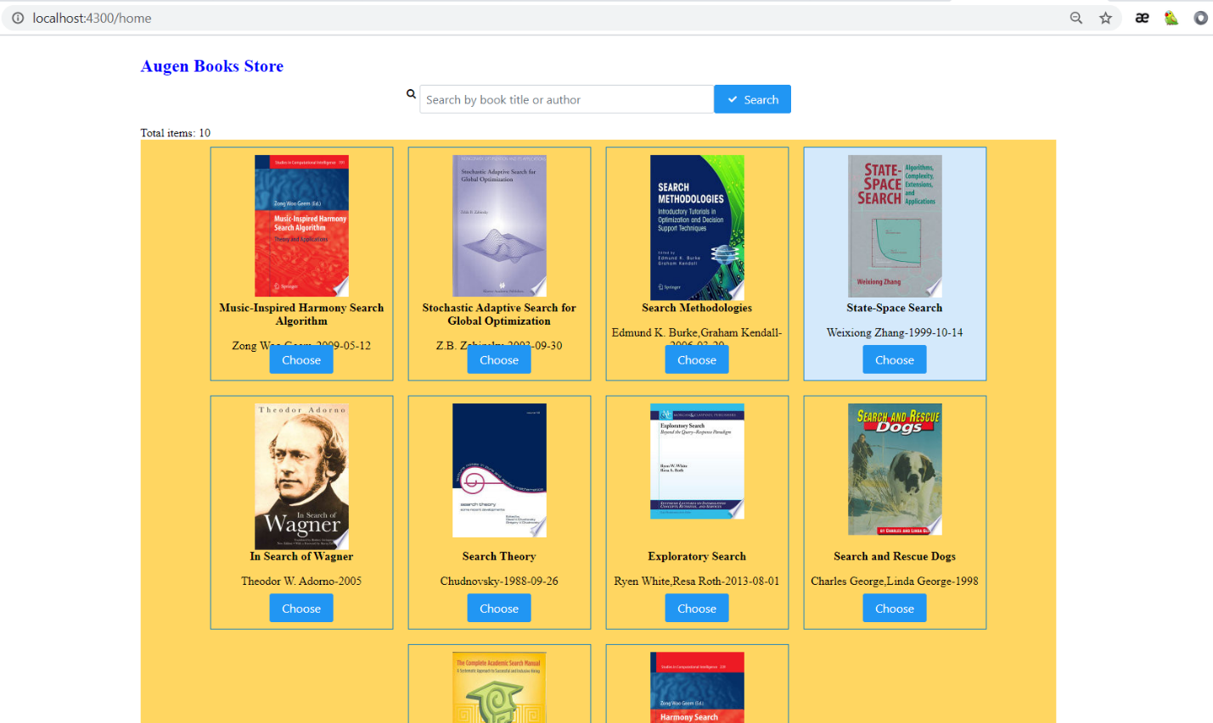

1. Select delivery service and Time and click “BUY” button to confirm

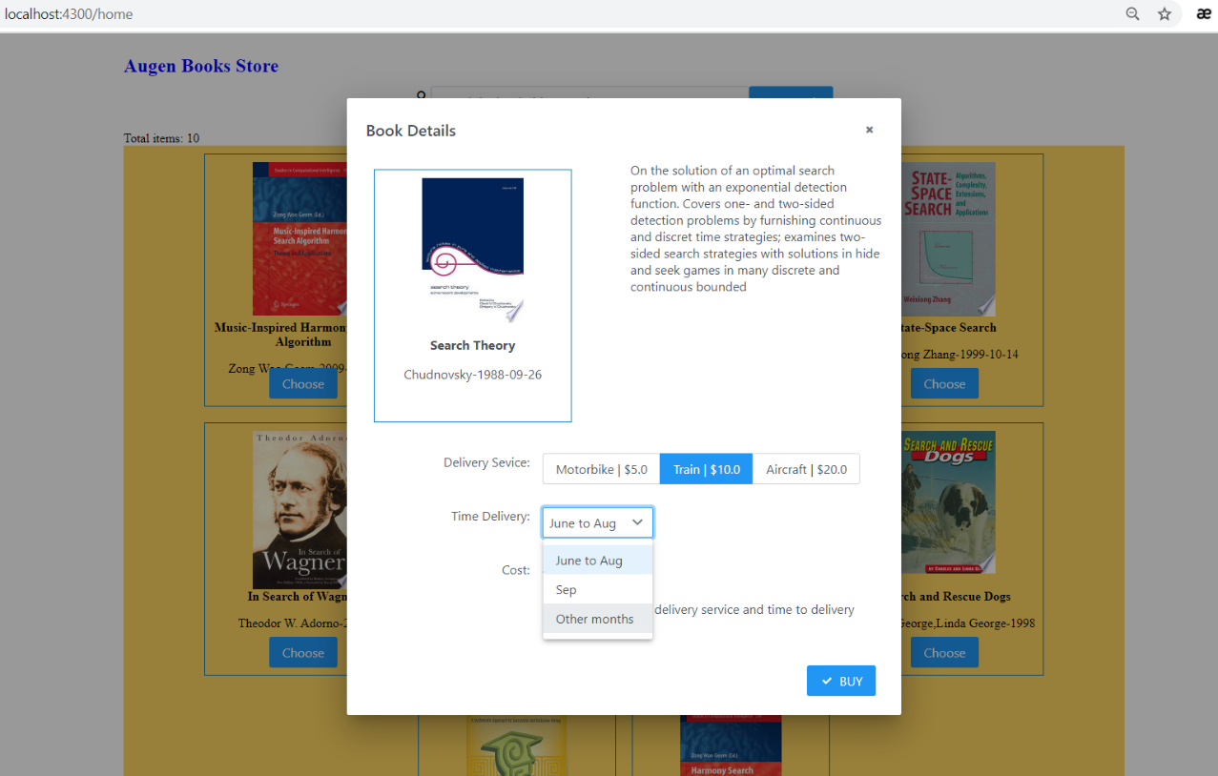

1. See the confirmation and click to “Continue to Buy” to back to homepage.

